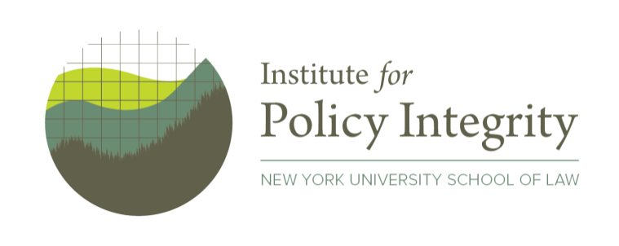
FOR IMMEDIATE RELEASE – January 19, 2021
Contact: Derek Sylvan | (614) 638-8282 | derek.sylvan@nyu.edu

New Report Clarifies Legal Standards for Corporate Climate Risk Disclosure Rule

As the SEC prepares a mandate for companies to disclose risks from climate change, new analysis highlights how the rule can withstand lawsuits.

Climate impacts are already threatening major economic sectors in novel ways and could cost the global economy trillions of dollars annually by 2100. Businesses—and the Americans invested in them—face both physical risks from extreme weather events and baseline temperature changes and transition risks as consumers and governments demand cleaner industry. Yet despite their serious implications, climate-related financial risks are under-disclosed by companies and are rarely reported in a way that is useful for investors.

As the Securities and Exchange Commission (SEC) prepares a new climate risk disclosure rule, a report from the Institute for Policy Integrity at NYU School of Law offers recommendations for assessing the policy’s economic impacts. Defending the rule’s economic analysis will be crucial in litigation, as trade groups have indicated intent to challenge any climate risk disclosure rule by claiming that its costs exceed its benefits.

The report analyzes relevant case law and highlights best practices that the SEC can follow in estimating the costs and benefits of the climate risk disclosure rule. By clarifying relevant legal standards, the report charts a path for the Commission to perform a legally durable economic analysis for a climate risk disclosure rule.

The full report, Assessing the Costs and Benefits of Mandatory Climate Risk Disclosure, is available at:
https://policyintegrity.org/documents/CBA_for_Mandatory_Climate_Risk_Disclosure_Report.pdf
The authors are available for interviews on these issues.
###
The Institute for Policy Integrity at New York University School of Law is a non-partisan think tank dedicated to improving the quality of government decisionmaking. The institute produces original scholarly research in the fields of economics, law, and regulatory policy; and advocates for reform before courts, legislatures, and executive agencies.

