- What is the Eastern Interconnection Planning Collaborative?

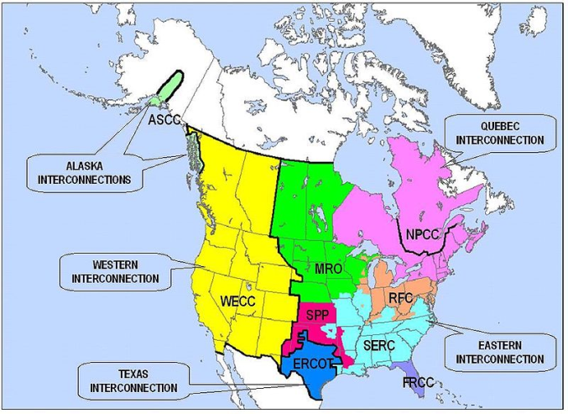The Eastern Interconnection Planning Collaborative (EIPC) was created by the transmission planning authorities in the Eastern Interconnection (which includes 39 states and much of Canada) and funded by the Department of Energy to conduct detailed modeling of potential resource scenarios and transmission needs for the next 10-20 years. You can find more information at www.eipconline.com.

- Why is EIPC important?

The EIPC was created to “develop long-term interconnection-wide transmission expansion plans” to encourage the development of “clean electricity”. The EIPC will model eight possible future energy generation scenarios (and 72 variations or “sensitivities” on those futures), and perform detailed analyses of three of those scenarios. The EIPC’s studies will likely influence future decisions regarding specific generation and transmission projects.

- EIPC decisions

EIPC decisions, including what scenarios to model, are guided by a Stakeholder Steering Committee (SSC). The SSC includes 29 sector representatives – state regulators, energy companies, transmission owners, end users, consumer advocates, environmental groups, one Canadian representative, etc. The environmental group/ non-governmental organization (NGO) representatives on the steering committee are Mark Brownstein (Environmental Defense Fund), Andy Oliver (Land Trust Alliance), and Beth Soholt (Wind on the Wires). NGO alternate steering committee members are Kit Kennedy (NRDC), John Moore (Environmental Law & Policy Center), and Wil Burns, Esq. (representing all 27 NGOs participating at EIPC).

